Automated Network Request Management in ServiceNow
Idea Prioritization
Date | 08 September 2026
Student Name | Ravipati Sri Sai Deepthi
Project Name | Automated Network Request Management in ServiceNow
Maximum Marks

Idea Prioritization
The prioritization below considers the main building blocks of the Automated Network Request Management project — request entry, form data, workflow automation, approvals, records, communication, security, and validation. Each item is rated High or Medium according to its contribution to a smoother request experience, implementation practicality, and dependency on other features.
Idea Group / Feature | Purpose in Project | Priority | Reason for Priority
Network Request Service Catalog | Service Catalog item (Category: Network) provides a standard starting point for employees to raise new or existing connection requests. | High | Creates a consistent entry point and avoids requests being handled through disconnected manual channels.
Network Request Form and Variables | Collects details such as Requested For, Mobile Number, Type of Connection, Existing ID, Total Amount, Mode of Payment, Address, and the Opened on Behalf Of variable set. | High | Improves the quality of information received by the fulfilment team and reduces back-and-forth with the requester.
Flow Designer Automation | Uses Get Catalog Variables, Create Record, Send Email, Ask for Approval, If/Else logic, and Update Record to move the request through defined stages after submission. | High | Connects the major steps into one automated lifecycle and reduces dependency on manual coordination.
Approval Routing | Uses the Ask for Approval action and Approval Request related list so requests can be reviewed before fulfilment. | High | Introduces a controlled checkpoint and makes the approval decision traceable.
Network Database Record Creation | Creates a Network Database record containing the information needed by administrators and the network fulfilment team to work on the request. | High | Provides one operational record for assignment, processing, approval information, and follow-up.
Dynamic Form Behaviour | Uses a Catalog UI Policy so the Existing ID field is shown when the requester selects an existing connection. | Medium | Keeps the form relevant to the selected connection type and avoids asking for unnecessary information.
Email Notifications | Uses the Send Email action to inform relevant users when important request events occur. | Medium | Keeps stakeholders informed without requiring them to repeatedly check the system.
Request Tracking / Status Visibility | Uses the Approval Status value on the Network Database record to indicate the current position of the request. | Medium | Helps users understand whether a request is awaiting action, approved, or requires attention.
Access Control | Applies ACLs and Access Control Rules to limit who can view or update sensitive Network Database information. | Medium | Supports role-based access and protects request information while depending on the underlying table design.
Validation and Testing | Checks mandatory data, form behaviour, record creation, notification steps, and approval outcomes through testing and User Acceptance Testing. | Medium | Helps identify workflow or data issues before the solution is used in the live environment.

Prioritization Overview
The card view below summarizes the main project components together with their assigned priority levels.
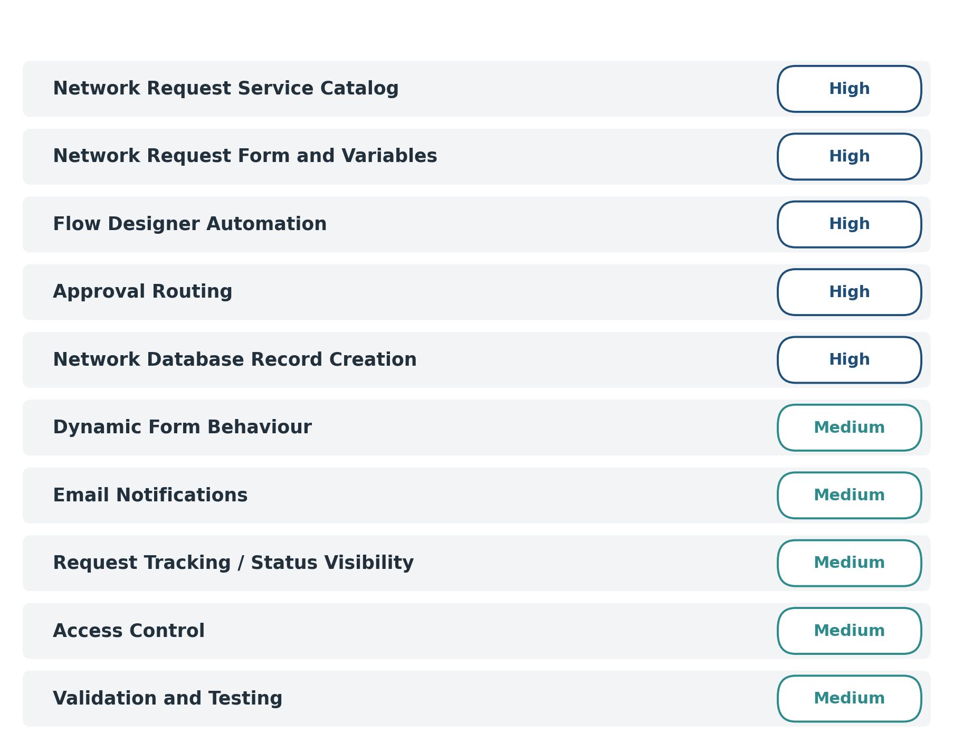
Figure 1: Prioritized representation of the Automated Network Request Management components.

